**Ethereal – MYTH**

**MYTH description**

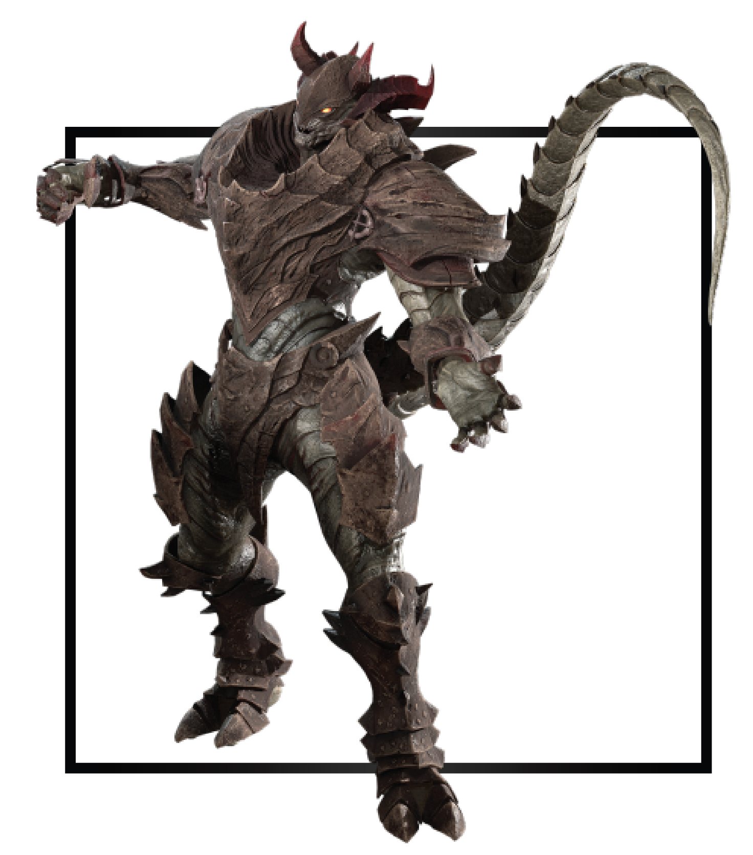

|  |  |
| --- | --- |
| **Name** | Arawn |
| **Title** | The Harbinger of Doom |
| **Realm** | Kraxus |
| **Region** | The Great Temple |
| **Class** | Berserker |
| **Type** | Melee Magical |
| **Release Date** | Coming Soon |

Led by Azrail, three Etherians forged the ultimate weapon of mass destruction. They cursed a demon with an infinite Thirst for vengeance and veins coursing with eternal pain. He had the sole purpose to gather and corrupt all Anima.

The demon paced around his throne room, deadly in battle and wrathful when restless. From the other end, a majestic Citadelian beast whimpered as imps dragged it across the hall towards the balcony to their master.

Whimpers grew into wailing as Arawn turned from the edge and crept back towards them. In one swift move, Arawn picked the beast up by the throat, Ire immediately rushed through his scalding flesh. The beast’s beautiful feathers triggered painful memories of a lost battle. The beast gargled as Arawn lifted it above his head. Visions of that fateful battle clouded his mind but he never broke eye contact One name rasped from his throat. Zero.

Sharp claws dug into pulsing flesh as he moved the creature over the edge and above the boiling whirlpools that surrounded his castle. Taking in every second of suffering, Arawn extracted the Anima from deep within the beast. Its body went limp as Cael’s essence, the animal’s life force, left its body. The once beautiful beast now a corpse, he threw the carcass over his shoulder for the demons to feast upon. With both hands, Arawn held the delicate essence that remained in front of his body.

A cruel smile spread across his face as he condemned the Anima into suffering only matched by his own. His arms extended and dropped the Anima down a path of misery, death, and eternal thirst for revenge.

Below the cliff, Anima blended among the whirlpools, bubbles thick as tar rose and burst to release violent poisonous gases. One bubble after another popped until the pool came to a full boil. After a pause, the pool ejected a wailing abomination towards the watershed. Anima forced back to roam the realms under Arawn's control and perpetuate the cycle of his ever-growing army.